PRESS RELEASE
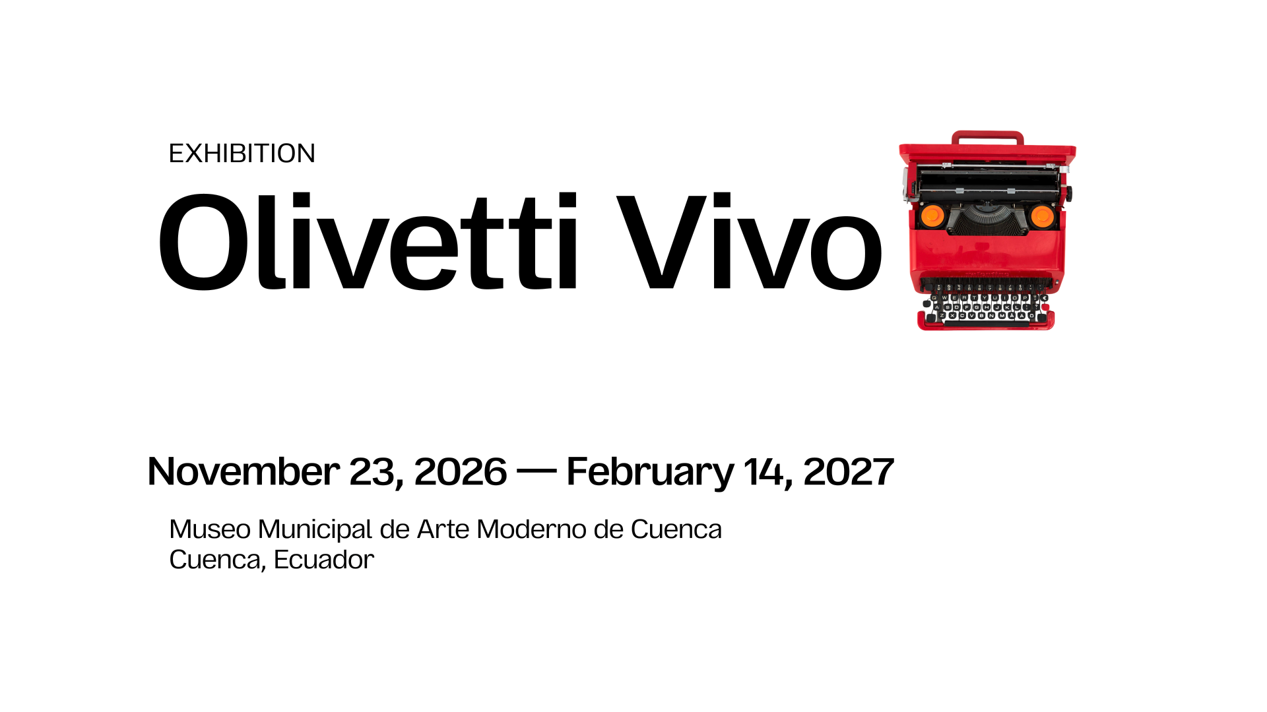

Olivetti Vivo.
Design, Culture, and Business in Ecuador
An exhibition and contest celebrating the legacy of «Stile Olivetti» and its projection towards the future
Download the press kit

Cuenca – Roma, June 10, 2026 – From November 23, 2026, to February 14, 2027, the Museo Municipal de Arte Moderno de Cuenca will host Olivetti Vivo, an international exhibition dedicated to the history and cultural legacy of the iconic Italian company Olivetti. The exhibition will officially open on Wednesday, November 25.

Meanwhile, as of June 10, the «Ser al centro» competition is officially open. This international contest, aimed at Latin American design students, invites participants to reinterpret the values of the Stile Olivetti through the contemporary design of posters.

EXHIBITION
This initiative, organized by the Universidad del Azuay, Associazione Archivio Storico Olivetti, Cappelli Identity Design, DAD-Dipartimento di Architettura e Design del Politecnico di Torino, MEI – Museo Nazionale dell’Emigrazione Italiana – MIC, and RUFA, brings one of the most significant examples of the integration of industry, design, culture, and social responsibility to Latin America. Designed under the creative direction of Cappelli Identity Design and based on the concept of «Proyección hacia el futuro» (Projection towards the future), the exhibition tells the story of the birth of Stile Olivetti. This corporate culture integrates product, architecture, graphics, and communication into a coherent system with design as its underlying structure. It features original objects, archival documents, posters, photographs, and iconic products, accompanied by experiments and workshops. Screenings of the documentaries Paradigma Olivetti and Prospettiva Olivetti, directed by Davide Maffei, are scheduled.

Olivetti Vivo
November 23, 2026 – February 14, 2027
Museo Municipal de Arte Moderno de Cuenca
Cuenca, Ecuador

Exhibition Opening: November 25, 2026
Full details to be announced on the website (https://olivetti.uazuay.edu.ec/)



CONTEST
In the frame of Olivetti Vivo exhibition and conference, the Universidad del Azuay, Cappelli Identity Design, and the Olivetti Historical Archive Association will launch «Ser al centro», an international design competition for Latin American students, in collaboration with RUFA. Based on the concept of «Proyección hacia el futuro», the contest places the human being and the community at the center as key elements of the project. Exclusively dedicated to poster design, the contest invites participants to reinterpret the values of Stile Olivetti in a contemporary manner. An international jury will evaluate the projects, and the finalists will have the opportunity to see their projects on display at the Museo Municipal de Arte Moderno de Cuenca during the exhibition. Three projects will be awarded Gold, Silver, and Bronze prizes.

Contest Rules:
full details to be announced on the website (https://olivetti.uazuay.edu.ec/)

***

This project was carried out with the support of our cultural partners: Casa Editora de la Universidad del Azuay, Museo Municipal de Arte Moderno de Cuenca, Davide Maffei - AirPixel.

Notes for editors
Universidad del Azuay was founded in 1968 and is headquartered in Cuenca, the capital of Ecuador's Azuay province. A non-profit organisation, it defines itself as “a community of faculty, staff and students who uphold the values of hard work, respect, pluralism, honesty, freedom, equity, solidarity, reciprocity and shared responsibility to support and promote learning”. The university's mission is to educate individuals who think critically, are ethically committed to society, and contribute to science and knowledge in order to achieve the comprehensive development of our environment. The university positions itself as an institution with a humanistic, dynamic, inclusive, respectful, open, flexible and free spirit dedicated to serving others. The university is committed to the Sustainable Development Goals, shaping its environment and management so that the university community plays a leading role in the equitable development of humanity and the conservation of our shared environment. It currently holds prominent positions in higher education rankings: It is ranked No. 1 for innovation and No. 3 overall in Ecuador in the Scimago Institutions Ranking; it is in the Top 5 for compliance with the UN Sustainable Development Goals in Ecuador; it is in the Top 7 among Ecuadorian universities according to the Global Web Ranking for Universities; it received an honourable mention in the Excellence Award from the International Sustainable Campus Network; and it received the “Sacha Unidos Hero” award in the “Solutions that promote sustainable and resilient construction” category, granted by the CEELA project.
Press contact
rector@uazuay.edu.ec +593 7 4091000
LinkedIn / Instagram / Facebook / X
Associazione Archivio Storico Olivetti, established in Ivrea in 1998 at the initiative of Olivetti Company in collaboration with the Fondazione Adriano Olivetti and major public and private partners, carries out activities of collecting, organising and preserving the documentary heritage relating to the history of the company and the Olivetti family. The Association has always been committed to cataloguing and digitising documents, which are progressively published on the Archivi Digitali Olivetti platform. Its specialist library, which is part of the Ivrea and Canavese Library System, also allows users to consult its catalogue online, thereby facilitating access for scholars and researchers. The Association collaborates on cultural projects and initiatives with private and public entities, curates a permanent exhibition on the Olivetti industrial project and organises exhibitions, events, conferences and publications to promote and deepen knowledge of Olivetti's history and values. The Association is also engaged in daily digital storytelling on major social media platforms and creates multimedia thematic tours on its website, primarily to reach an increasingly broad, international and multigenerational audience.
Press contacts
segreteria@archiviostoricolivetti.it +39 0125641238
Facebook / Instagram / Linkedin / X / YouTube / Spotify / Threads
#StoriaDiInnovazione

Cappelli Identity Design, Founded in Rome in 2010 by Emanuele Cappelli, is an independent studio specialising in design, communication and digital strategies, using the Dynamic brand methodology. The studio creates multidisciplinary projects at national and international levels and is recognised with awards from the ADI Compasso D’Oro International Award, the World Brand Design Society, the German Design Awards and many others. Cappelli Identity Design is also a member of ADI, the World Design Organization and the Olivetti Historical Archive Association. The studio's areas of expertise include strategy and positioning, Dynamic Brand, advertising, events, exhibitions, editorial and digital design, and social media marketing. This enables the studio to flexibly meet the needs of institutional and private clients such as the Olivetti Historical Archive Association, Cinecittà, Emirates, the Adriano Olivetti Foundation, the CRT Foundation, the TIM Foundation, the Inovara Group, ITA Airways, Olivetti, Logista, Terna, TIM, Snam, Sparkle, and WAY. With offices in Rome and Turin, the studio has established itself as a leading player in the contemporary design, marketing and communications landscape. It is part of the Mad Genius Group.
Press contacts
Fabio Zanino, communication@cappellidesign.com +39 3474585473
LinkedIn / Instagram / Facebook / X / Threads
#DynamicBrand

MEI – Museo Nazionale dell'Emigrazione Italiana (National Museum of Italian Emigration), located in Genoa, was established through an agreement between the Ministry of Culture, the Liguria Region, and the Municipality of Genoa, with the aim of telling the many facets of Italian migration from the Unification of Italy to the present day. The multimedia exhibition can be visited inside the Commenda di San Giovanni di Pré, restored for the occasion, and is closely connected to Mu.MA – Institution of the Sea and Migration Museums and the Galata Museo del Mare. From Genoa, millions of Italians set out for the Americas, Africa, Asia, Australia, and Europe, leaving everything behind to embark on a journey with no return. MEI was created to remember these migrants and to tell their stories and the reasons behind their departure from a human, historical, and sociological perspective. An innovative multimedia museum, MEI allows visitors to interact with spaces and objects and experience immersive journeys through state-of-the-art technology. Visitors can see, listen, learn, and test themselves through scenic installations housed in one of the city’s oldest medieval buildings. The Museum is open Tuesday through Saturday, from 10:00 a.m. to 6:00 p.m.
Press contacts
Eleonora Errico, Arianna Del Ponte, stampa@museomei.it +39 3351002079, +39 346 690 7326
Instagram / Facebook

Politecnico di Torino, founded amid a wave of renewal in technical and scientific culture that saw the emergence of Europe’s most prestigious polytechnics in the mid-19th century, is Italy’s first engineering school. Originally established in 1859 as the School of Applied Engineering, it became the Royal Polytechnic of Turin in 1906. For over 160 years, Politecnico di Torino has trained professionals in engineering, architecture, design and urban planning to the highest standards of integrity and rigour. Recognised by international rankings as one of Europe’s leading technical universities, it has more than 38,800 students, 22% of whom are international and hail from 122 countries. The Politecnico di Torino positions itself as a centre of excellence for education and research in engineering, architecture, design, and planning, maintaining close ties with the socio-economic sector.
Press contacts
Resp. Antonella Massia – Anita Botta, Iride Lucrezia Rosso, relazioni.media@polito.it
LinkedIn / Instagram / Facebook / YouTube / TikTok

RUFA, Rome University of Fine Arts, is a multidisciplinary and international institution of higher education in the arts, legally recognized by the Italian Ministry of University and Research (MUR). It offers accredited and innovative programs in the fields of the arts, design, visual communication, audiovisual arts, fashion, gaming, and multimedia arts. RUFA’s educational approach is innovative and specialized, aiming to combine the university curriculum with professional training: throughout their studies, RUFA students participate in and attend labs, workshops, experiential classes, exhibitions, presentations, and debates. All tools that help them forge a real connection with the professional world.
Press contacts
Ernesto Pastore, ernesto.pastore@unirufa.it +39 389342566
LinkedIn / Instagram / Facebook / YouTube / TikTok

